Interpolate_Time.XLS Documentation
This document explains how to use the interpolate_time.xls spreadsheet. This spreadsheet facilitates the creation of SL or %Shortening versus Ca plots (or really plots of anything versus anything) in cases where the two things you want to plot were sampled at different frequencies.

Step 1: Set up the data in IonWizard  You will need to export the data you want from IonWizard into excel. The easiest way is to export to the clipboard.  First prepare the data by having only 2 trace viewers open. Select the slower data (usually edge/SL) into the first viewer and select the faster data (usually Ca) into the second viewer.  In the parlance of the excel spreadsheet, the slower data is the “From” data and the faster data is the “To” data. |  | 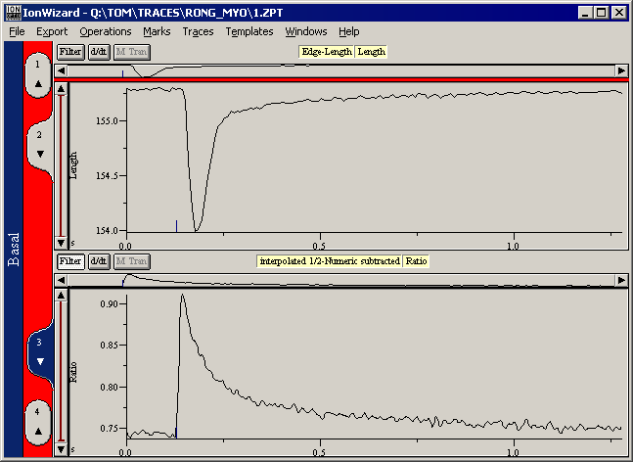
Step 2: Open the Spreadsheet.  Open the interpolate_time.xls spreadsheet. You will get a dialog box saying that there are macros. You must Enable Macros for this to work. | 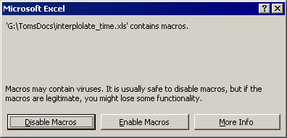
Step3: Empty the Spreadsheet  The spreadsheet should be empty when you start. | 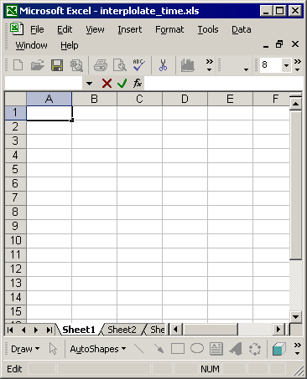
Step 4: Export the Data from IonWizard  Use the Export Current option to export the two traces to the clipboard. | 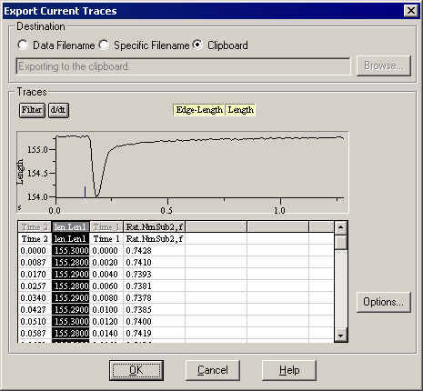
Step 5: Paste the data into Excel  Select the A1 cell in Excel and the select Paste from the Edit menu | 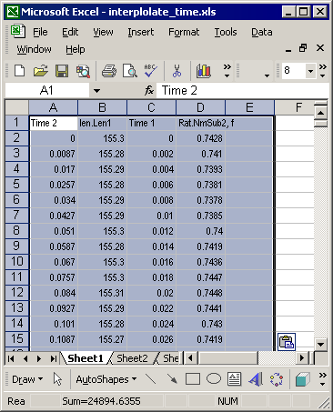
Step 6: Prepare to Run the Macro  Select the upper leftmost data cell in the “From” times. | 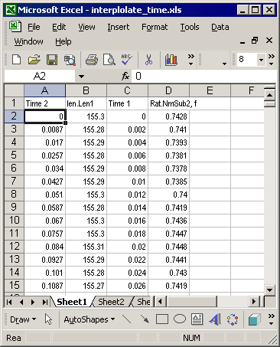
Step 7: Run the Interpolation Macro  Select the “Tools” menu. Find the “Macro” submenu and then select the “Macros…” item. You will see the following dialog box. (In Office 2007, Macros are located under the “View” tab.)  The macro, when run, interpolates the From data (i.e. SL) to the To data (i.e. Ca) times. It can optionally also create two plots.  The first plot is a validation plot that overlays the raw from data with its interpolation.  The second is the actual loop plot.  The 4 macro options let you choose one plot, both plots or no plots (interpolation only). | 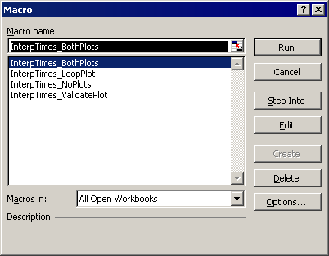
Step 8: Pick Loop Plot X Axis  The loop plot can display either the To (i.e. Ca) or the From (i.e. SL) data on the X Axis. You make this choice via the dialog box shown here. | 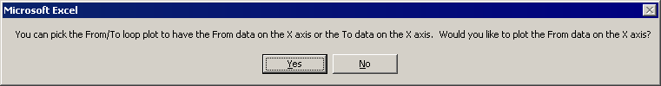
Step 9: Examine Results  The macro should then fill in a 5th column with the interpolated amplitudes and generate the desired plots. The figure here illustrates both plots. | 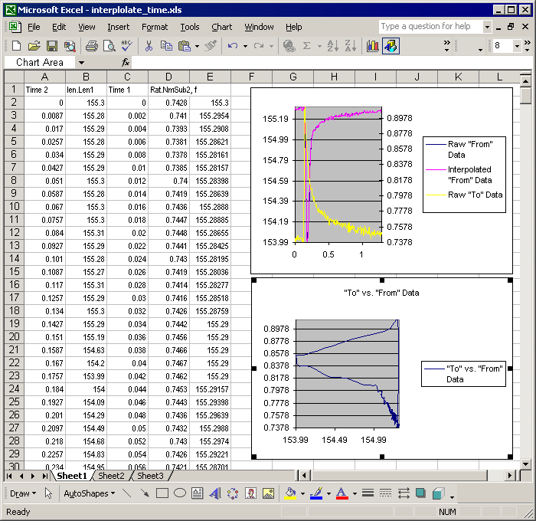
Step 10: Prepare for Next Plot(s)
If you intend to generate more plots, you will want to either “Save As” this file under a separate name to preserve the original interpolate_times.xls file, or delete everything.

